MLA 01 ARTIFICIAL INTELLIGENCE AND EXPERT SYSTEMS

- Consider a simple knowledge base describing who loves whom. Define the following relationships in Prolog and write a query to find out who loves someone named "Alice."
  - loves(john, mary)
  - loves(jane, peter)
  - loves(peter, alice)
  - loves(john, alice).

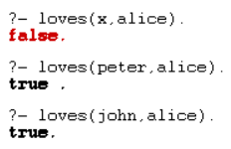

- Write a Prolog program containing facts related to following predicates
  - Location (city, state)
  - Stays (person, city)
  - Display: list of persons, state and city
  - Given person, find the state in which he is staying.

location(chennai, tamil_nadu).
location(coimbatore, tamil_nadu).
location(mumbai, maharashtra).
location(pune, maharashtra).
location(jaipur, rajasthan).
location(kolkata, west_bengal).

stays(ram, chennai).
stays(sita, mumbai).
stays(john, pune).
stays(anita, jaipur).
stays(rahul, kolkata).
display(Person, City, State) :-
stays(Person, City),
location(City, State).

state_of_person(Person, State) :-
stays(Person, City),
location(City, State).

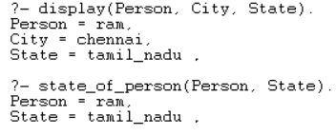

- Write a Prolog program that answers bout family members and relationships. Include predicates & clauses which defines sister, brother, father, mother, Grandchild, Grandfather and uncle. The program should be able to answer question such as following :
  - Father(X, bob)
  - Grandson(X,Y)
  - Uncle (bill, Sue)
  - Mother (marry, X).

male(john).
male(bob).
male(bill).
female(mary).
female(sue).

father(john, bob).
father(john, mary).
father(bob, sue).

mother(mary, sue).

% brother
brother(X, Y) :-
male(X),
father(F, X), father(F, Y),
X \= Y.

% sister
sister(X, Y) :-
female(X),
father(F, X), father(F, Y),
X \= Y.

% grandchild
grandchild(X, Y) :-
father(Y, P), father(P, X);
father(Y, P), mother(P, X);
mother(Y, P), father(P, X);
mother(Y, P), mother(P, X).

% grandfather
grandfather(X, Y) :-
male(X),
grandchild(Y, X).

% uncle
uncle(X, Y) :-
male(X),
father(F, Y),
brother(X, F).

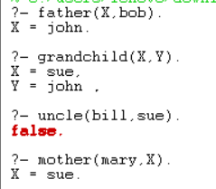

- Write simple fact for the statements using PROLOG
  - Every boy or girl is a child
  - Every child gets a doll or a train or a lump of coal
  - No boy gets any doll
  - no child who is good gets any lump of coal
  - Jack is a boy.

boy(jack).
girl(lily).

child(X) :- boy(X).
child(X) :- girl(X).

gets(X, doll) :- child(X).
gets(X, train) :- child(X).
gets(X, coal) :- child(X).

gets(X, doll) :- boy(X), !, fail.

good(jack).

gets(X, coal) :- good(X), !, fail.

boy(jack).

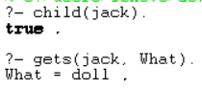

- Write predicates, one converts centigrade temperatures to Fahrenheit, the other checks if a temperature is below freezing using PROLOG.

c_to_f(C, F) :-
F is (9/5)*C + 32.
below_freezing(T) :-
T < 0.
